Functional Programming

📌 Definition:
# Source: AI Source: Provided by: [Data Path: Persons Table -> ID Column: 1, Name_En Column: Motasem Essam] -> From: [Chatgpt (GPT‑5 Mini)] on [12/9/2025]
Functional programming is a paradigm that focuses on using functions as the main building blocks, emphasizing pure functions and immutable data.

🧠 Simple idea:
# Source: AI Source: Provided by: [Data Path: Persons Table -> ID Column: 1, Name_En Column: Motasem Essam] -> From: [Chatgpt (GPT‑5 Mini)] on [12/9/2025]
Functional = “Input → Process → Output” 🔁

🔍 Key characteristics:
# Source: AI Source: Provided by: [Data Path: Persons Table -> ID Column: 1, Name_En Column: Motasem Essam] -> From: [Chatgpt (GPT‑5 Mini)] on [12/9/2025]
- 🧩 Programs are built using functions
- 🔒 Immutable data (no changes to original data)
- ⚙️ Pure functions (same input → same output, no side effects)
- 🔄 Avoids changing state and mutable variables
- 🧠 Focus on what to compute, not how

📌 Example (JavaScript):
# Source: AI Source: Provided by: [Data Path: Persons Table -> ID Column: 1, Name_En Column: Motasem Essam] -> From: [Chatgpt (GPT‑5 Mini)] on [12/9/2025]
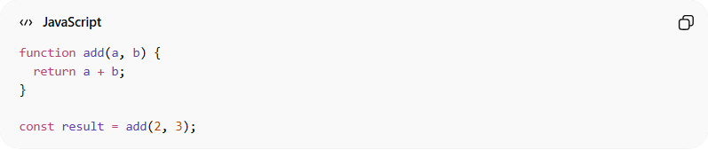
function add(a, b) {
return a + b;
}

const result = add(2, 3);
👉 The function:
- Takes input (a, b)
- Returns output
- Does not change anything outside

📌 Example (Higher-order function):
# Source: AI Source: Provided by: [Data Path: Persons Table -> ID Column: 1, Name_En Column: Motasem Essam] -> From: [Chatgpt (GPT‑5 Mini)] on [12/9/2025]
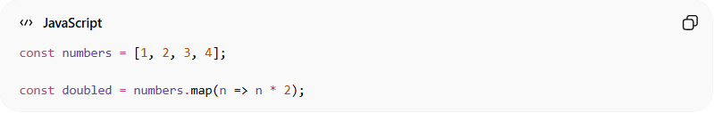
const numbers = [1, 2, 3, 4];

const doubled = numbers.map(n => n * 2);
👉 Uses functions as arguments and returns new data.

⚙️ Real-world languages:
# Source: AI Source: Provided by: [Data Path: Persons Table -> ID Column: 1, Name_En Column: Motasem Essam] -> From: [Chatgpt (GPT‑5 Mini)] on [12/9/2025]
- 🟢 Haskell
- 🟢 Scala
- 🟢 Lisp
- 🟢 JavaScript (supports functional style)
- 🟢 Python (supports functional features)

🔁 Functional Programming vs 🔄 Procedural Programming

🧠 Core Idea:
# Source: AI Source: Provided by: [Data Path: Persons Table -> ID Column: 1, Name_En Column: Motasem Essam] -> From: [Chatgpt (GPT‑5 Mini)] on [12/9/2025]
- 🔁 Functional Programming → Focus on functions and data flow
- 🔄 Procedural Programming → Focus on step-by-step instructions

⚖️ Key Differences:
# Source: AI Source: Provided by: [Data Path: Persons Table -> ID Column: 1, Name_En Column: Motasem Essam] -> From: [Chatgpt (GPT‑5 Mini)] on [12/9/2025]
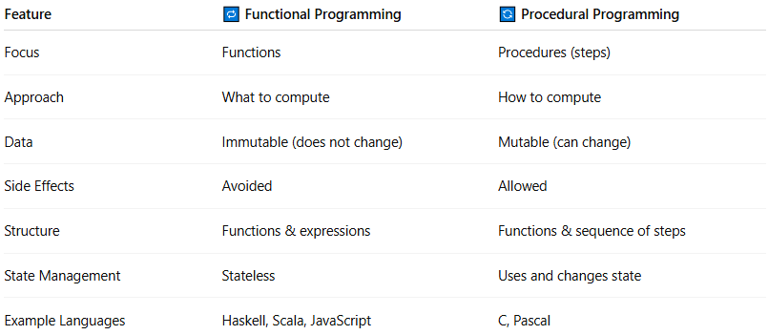
Feature | 🔁 Functional Programming | 🔄 Procedural Programming
Focus | Functions | Procedures (steps)
Approach | What to compute | How to compute
Data | Immutable (does not change) | Mutable (can change)
Side Effects | Avoided | Allowed
Structure | Functions & expressions | Functions & sequence of steps
State Management | Stateless | Uses and changes state
Example Languages | Haskell, Scala, JavaScript | C, Pascal

📌 Example Comparison:

🔁 Functional Style:
# Source: AI Source: Provided by: [Data Path: Persons Table -> ID Column: 1, Name_En Column: Motasem Essam] -> From: [Chatgpt (GPT‑5 Mini)] on [12/9/2025]
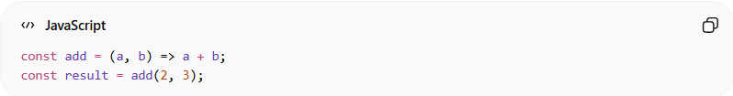
const add = (a, b) => a + b;
const result = add(2, 3);
👉 Pure function, no side effects.

🔄 Procedural Style:
# Source: AI Source: Provided by: [Data Path: Persons Table -> ID Column: 1, Name_En Column: Motasem Essam] -> From: [Chatgpt (GPT‑5 Mini)] on [12/9/2025]
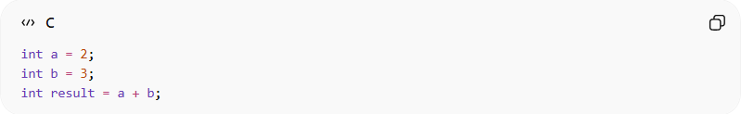
int a = 2;
int b = 3;
int result = a + b;
👉 Uses variables and step-by-step execution.

🧠 Key Concept Difference:
# Source: AI Source: Provided by: [Data Path: Persons Table -> ID Column: 1, Name_En Column: Motasem Essam] -> From: [Chatgpt (GPT‑5 Mini)] on [12/9/2025]
- 🔁 Functional → “What result do I want?”
- 🔄 Procedural → “What steps should I follow?”

🎯 Summary:
# Source: AI Source: Provided by: [Data Path: Persons Table -> ID Column: 1, Name_En Column: Motasem Essam] -> From: [Chatgpt (GPT‑5 Mini)] on [12/9/2025]
Functional programming focuses on pure functions and immutability, while procedural programming focuses on executing a sequence of steps to achieve a result.

🆚 Functional vs Other Paradigms
# Source: AI Source: Provided by: [Data Path: Persons Table -> ID Column: 1, Name_En Column: Motasem Essam] -> From: [Chatgpt (GPT‑5 Mini)] on [12/9/2025]
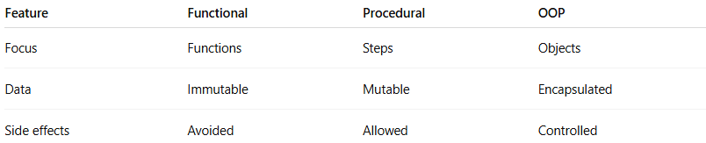
Feature | Functional | Procedural | OOP
Focus | Functions | Steps | Objects
Data | Immutable | Mutable | Encapsulated
Side effects | Avoided | Allowed | Controlled

🎯 Summary:
# Source: AI Source: Provided by: [Data Path: Persons Table -> ID Column: 1, Name_En Column: Motasem Essam] -> From: [Chatgpt (GPT‑5 Mini)] on [12/9/2025]
Functional programming solves problems using pure functions and immutable data, making programs predictable, easier to test, and less error-prone.

